Exposure Of a Line Cook to Indoor Pollutants

**Zachary Golden**

Portland State University Maseeh College of Engineering and Computer Science, Portland, OR, US

Abstract

*At a busy restaurant that is compliant with local health department ventilation codes, the indoor air quality was tested for an employee working on the line. For a portion of the study, the sensor was worn by the employee, and the other portion the sensor was stationary. While the ventilation removes pollutants from the indoor space, the line cook standing over the fumes is in the direct path of removal, being exposed to high levels of pollutants. When the sensor was placed outside the hoods, the PM2.5 concentration still reached hazardous levels. For the duration of the period of observation, the PM2.5 levels were above the EPA’s long term exposure limit of 12 μg/m3. For much of the observation, except for brief periods where the restaurant was closed for transition from lunch service to dinner service, the PM2.5 levels were above the EPA’s short term exposure limit of 35 μg/m3.*

Keywords: PM2.5, Line Cook, Indoor Air Quality, Exposure

Nomenclature

|  |  |
| --- | --- |
| PM2.5 | Particulate matter suspended in the air with a diameter of 2.5 μm or less. |
| TVOC | Total Volatile Organic Compounds |
| eCO2 | Effective Carbon Dioxide |

1. INTRODUCTION

The author of the paper is the line cook referred too. While working it was apparent that, although beneath a powerful hood ventilation system, an employee’s nose and mouth is above the pans emitting the fumes, and the employee inhales the unmitigated pollutants of the cooking process. It is also noted that as one transfers a dish from a pan to the plate, the pans are swung away from the ventilation system. This is a common practice in the restaurant industry, plating the dishes on a separate table away from the ventilation. Employees that are not working on the line report noticeable irritation from the fumes produced by the cooking process that are not captured by the hood ventilation system, as well as customers seated in the dining room. Thus, the motivation for the study. As a more concrete question: What is the PM2.5 exposure for the employee who is stationed above the pots and pans, and what are the levels of PM2.5 away from the hood ventilation system?

1. **MATERIALS AND METHODS**

Two sensors were employed to determine exposure to indoor pollutants. One was used to measure particulate matter and the other is used to measure effective CO2 and total volatile organic compounds. The two sensors were connected to an Arduino board with an SD card to write the data.

**2.1 Adafruit PMSA003I Air Quality Breakout**

The company Adafruit created a printed circuit board that allows for easy interfacing with a PLANTOWER PMSA003I particulate sensor. The sensor is not accurate measuring particles with a diameter greater than 2.5 μm when compared to a known accurate sensor. However, it measures PM2.5 accurately when compared to the same sensor [1]

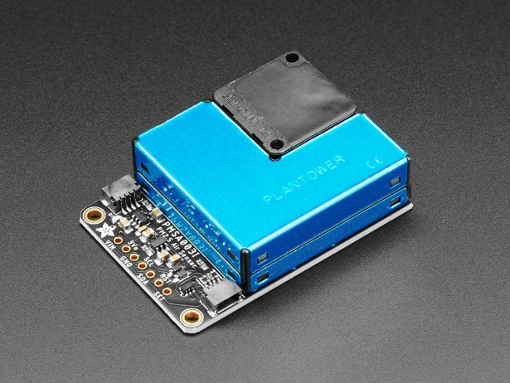

**FIGURE 1:** ADAFRUIT PMSA003I AIR QUALITY BREAKOUT (Image Credit: Adafruit Industries)

* 1. **Adafruit SGP30 Air Quality Sensor Breakout**

The SGP30 is a low-cost sensor that estimates CO2 and TVOC levels by using helium and ethanol readings to calculate an estimated value. TVOC is a lumped approximation of the volatile organic compounds in a space. A high TVOC value does not necessarily mean that there is a danger, it is more of a reason to investigate if there is a dangerous volatile organic compound contributing to the high TVOC level. While CO2 is not dangerous except for at very high levels, it can be used as a proxy to determine the ventilation in a space. If there are a lot of people in a room as a source of CO2, and the levels continue to accumulate, then it could be inferred that the building is not bringing in enough outside fresh air.

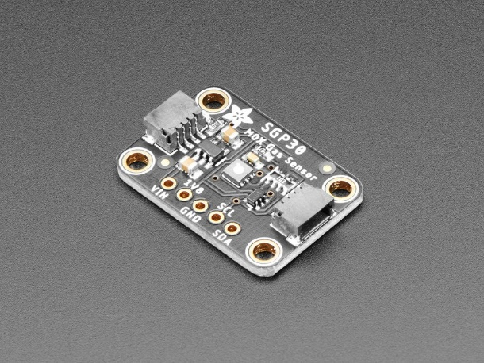

**FIGURE 2:** ADAFRUIT SGP30 AIR QUALITY BREAKOUT (Image Credit: Adafruit Industries)

**2.3 Sensor Data Recording Method**

The two sensors were connected to an Adafruit Feather M0 Adalogger. The system was powered by battery, or a USB connection and the data was recorded every five minutes onto a microSD card.

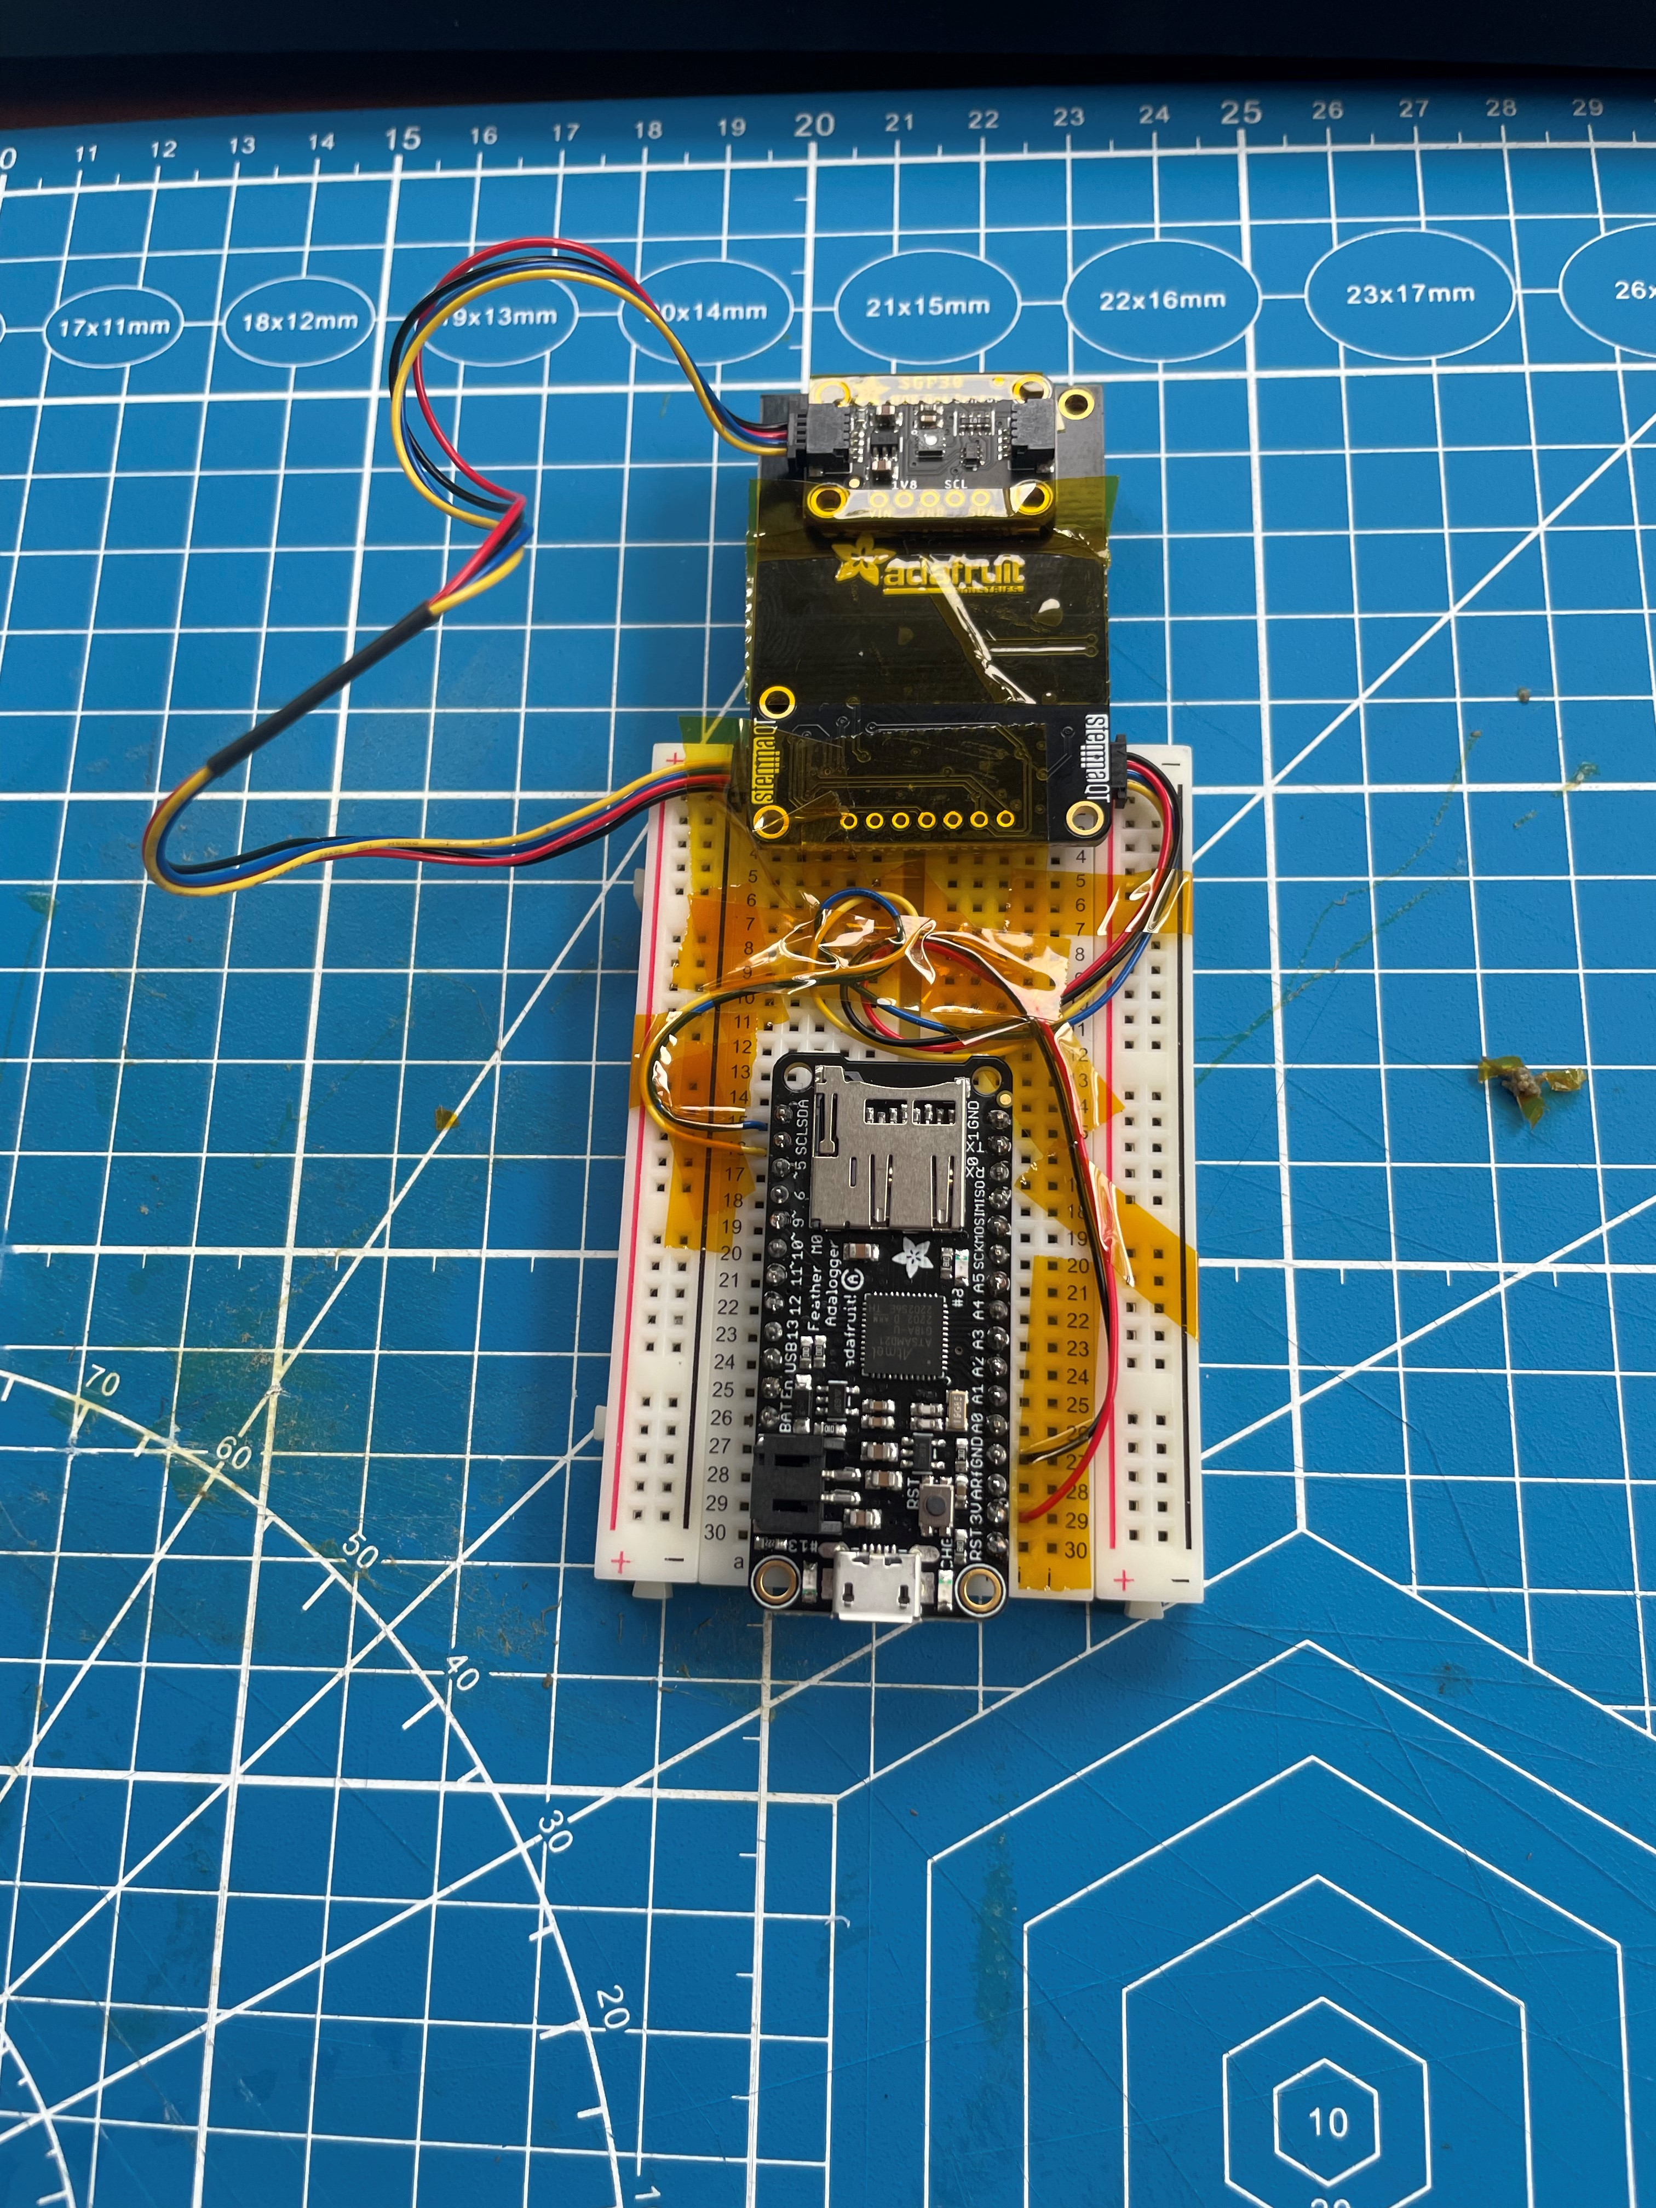

**FIGURE 3:** CONNECTED SENSORS TO MAIN BOARD

**2.4 Data Collection Method**

The data for the study was collected in two ways. First, the sensor was worn while cooking underneath the hood ventilation system. The original plan was for all the data to be collected this way. Due to incorrect selection of the battery, the system was only able to last for 30 minutes on battery power. For the remainder of the study, the device was placed on a nearby shelf, not under the hood ventilation system, connected to USB power. However, this error allows for the comparison of the air quality of a person working under the hood vent, versus a person working nearby. Data collection was started in the morning, and readings were gathered while making breakfast before work, and there was also data driving to work and home from work. For control data, the device was set up in the authors apartment and left on a dresser in a bedroom and collected data all night.

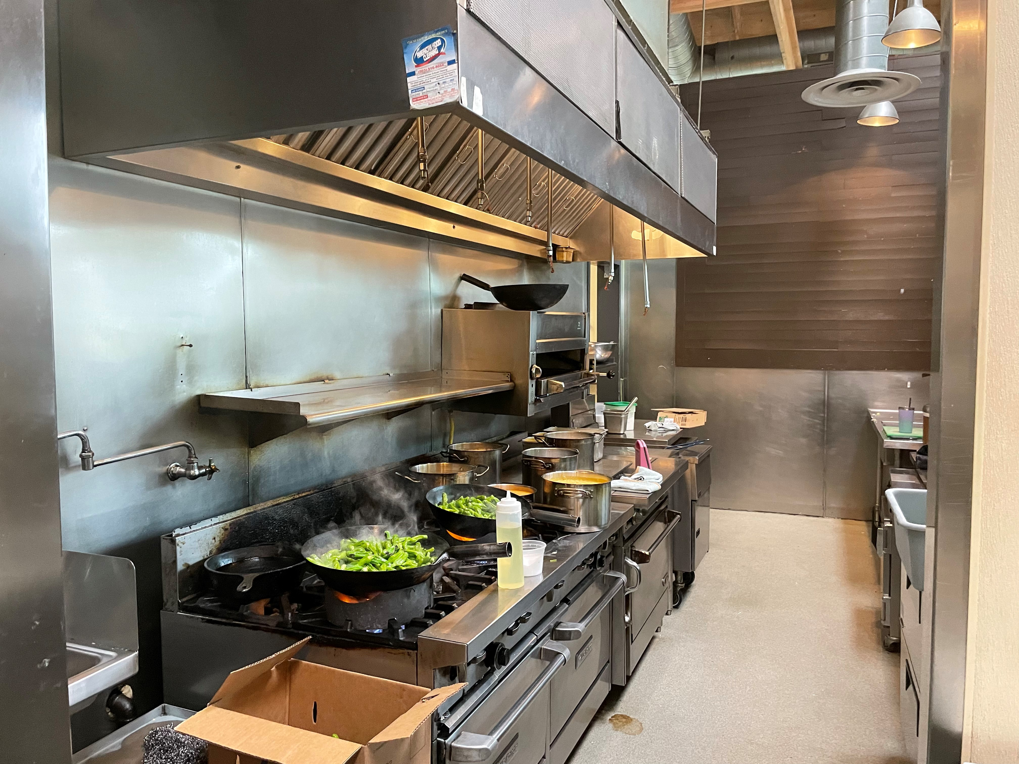

**FIGURE 4:** DEVICE WAS WORN WHILE WORKING AT WOK STATION UNDERNEATH HOOD VENTS

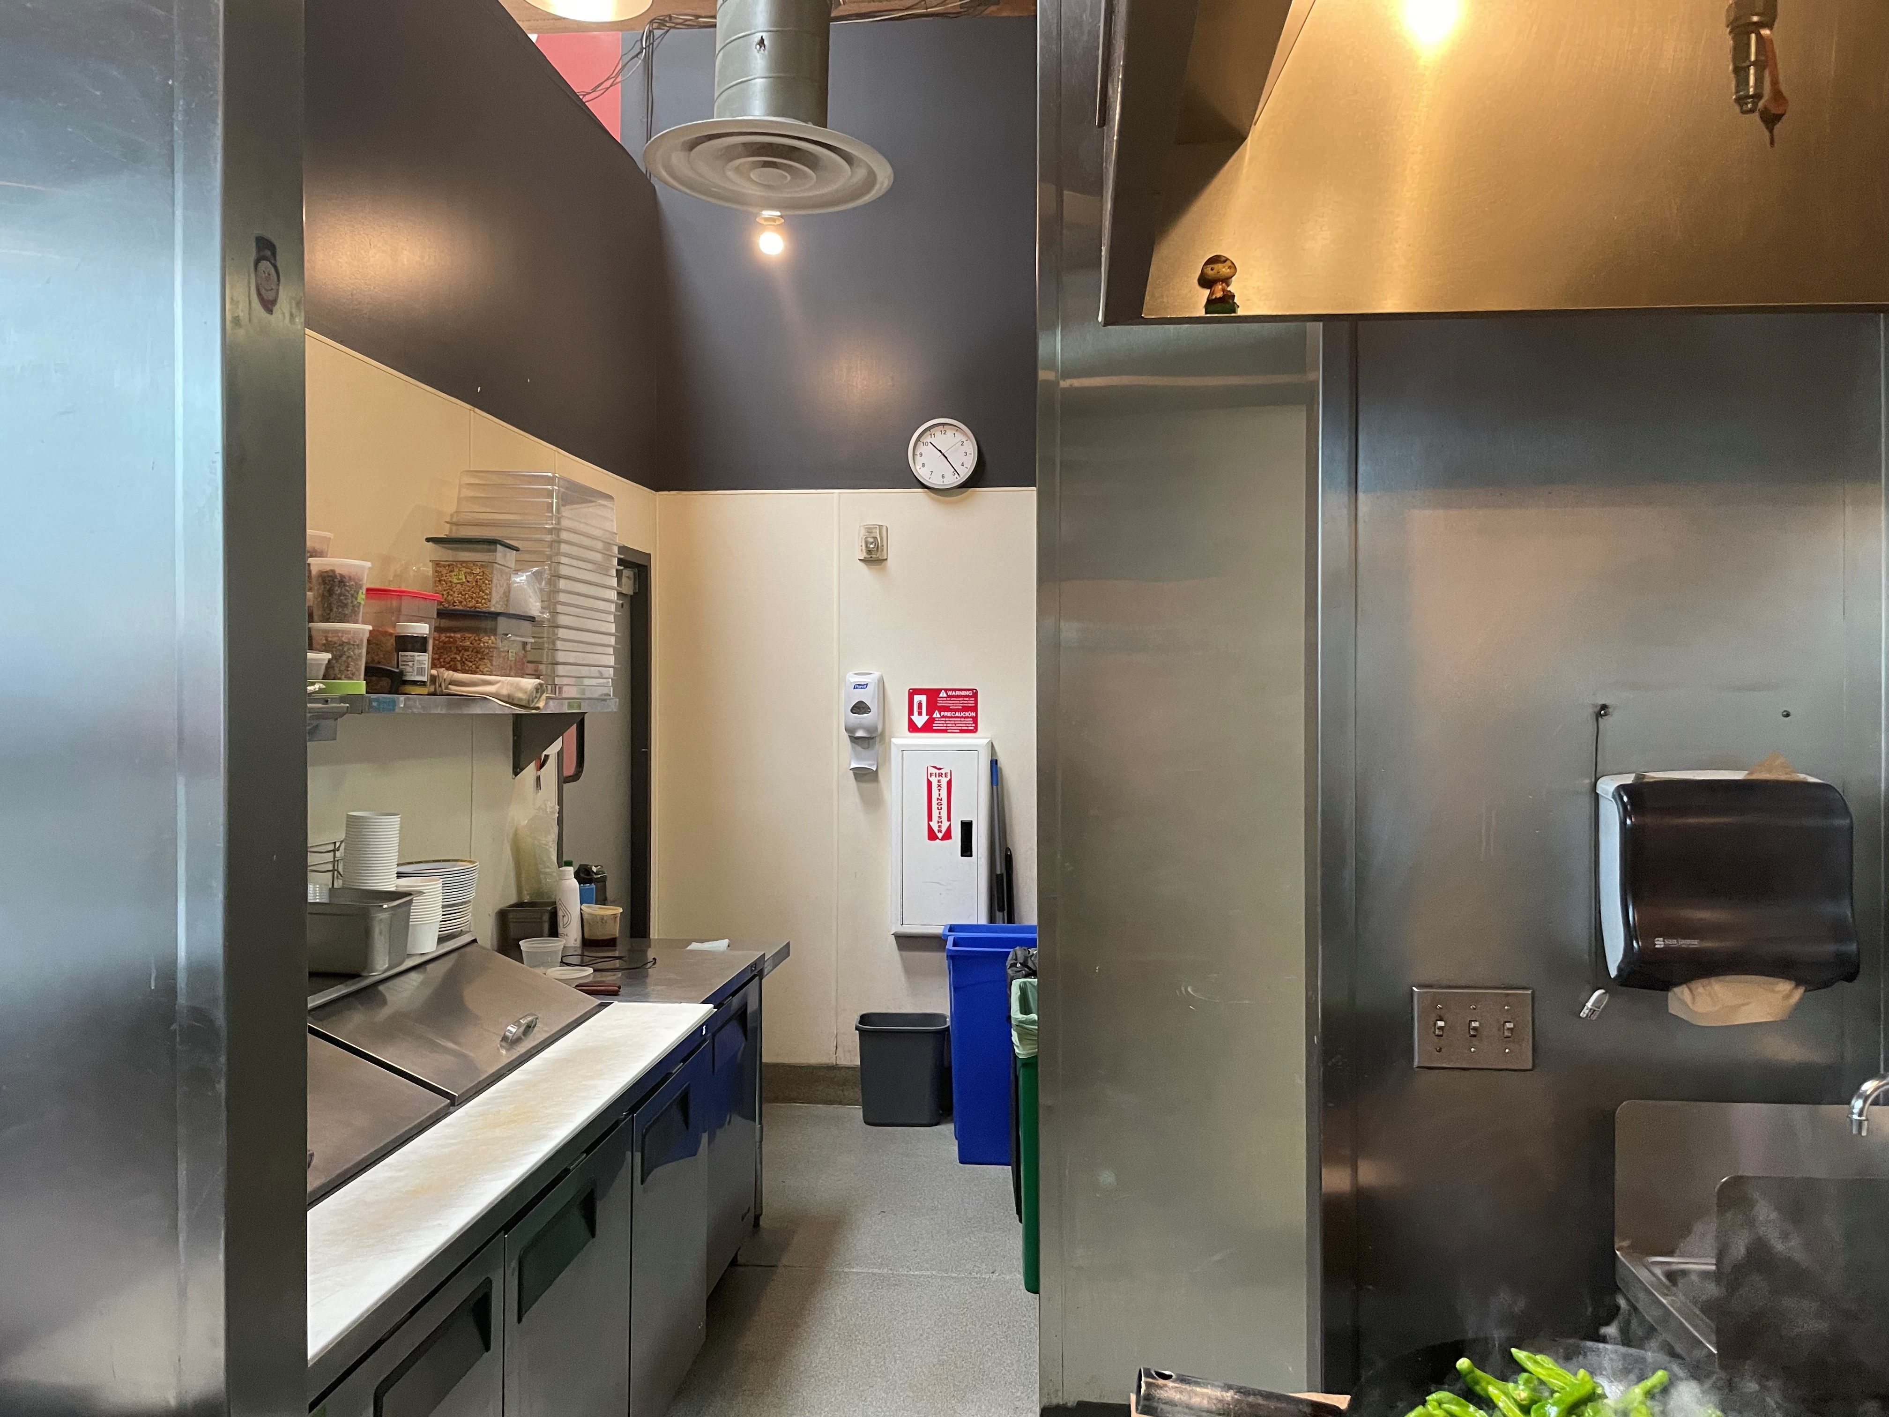

**FIGURE 5:** DEVICE WAS PLACED ON SHELF AS INDICATED BY YELLOW CIRCLE. NOTE PROXIMITY TO HOOD VENT FROM PREVIOUS PICTURE WITH THE WOK AS REFERENCE

1. **RESULTS AND DISCUSSION**

The data was processed using a custom MATLAB script with some recommended exposure levels plotted on the collected data.



**FIGURE 6:** EXPOSURE TO PM2.5 STANDARD CONCETRATION AS A FUNCTION OF TIME

The sensor outputs to different versions of PM2.5, one labeled standard concentration and one labeled environmental concentration. The environmental concentration seems to be correcting for a factor, and the concentrations measured at the same time are lower than the standard results.



**FIGURE 7:** EXPOSURE TO PM2.5 ENVIROMENTAL CONCETRATION AS A FUNCTION OF TIME

In either case, the two plots clearly show hazardous PM2.5 while at work. The two horizontal lines represent standards decided by the environmental protection agency. The yellow line is the long-term annual exposure limit of 12 μg/m3 and the red line is the short-term 24-hour exposure of 35 μg/m3.[2]

The large spike centered on the 200-minute mark is the period where the device was worn underneath the hood vent. For this location the exposure is extremely high. The resolution for this period is low since the sample rate was set at once every 5 minutes. Although from experience in the position, it is known that this level of fumes is consistent throughout the operating hours. It is recommended that the data be recollected while being worn at a higher sampling rate. This was attempted, but the data was corrupted so no results can be presented. This result is a high safety concern for the individuals working underneath the hood ventilation system, they are being exposed to very dangerously high levels of PM2.5 at all operating hours of the day while working above the pans, underneath the hood ventilation.

Although the concentration is less for the period when the device is setting on the shelf, it is still consistently above the EPA short term exposure level. The EPA states, “Exposure to fine particle pollution can cause premature death and harmful cardiovascular effects such as heart attacks and strokes, and is linked to a variety of other significant health problems.” [2]



**FIGURE 8:** eCO2 CONCENTRATION AS A FUNCTION OF TIME

The levels of CO2 are not of concern during the working hours. The time of worst ventilation was during the commuting period, while in the car with all the windows rolled up and no outside air flowing.



**FIGURE 9:** TVOC CONCENTRATION AS A FUNCTION OF TIME

The TVOC exposure is relatively low in comparison. The highest areas of concern were during the time underneath the hood vent and in the car. However TVOC does not necessarily indicate harmful volatile organic compounds, but the presence of a high amount of volatile organic compounds. The reigons of concern where taken from the Environmental Analytical service, and currently there are no governmental regulations on TVOC. [3]



**FIGURE 10:** CONTROL EXPOSURE TO PM2.5 STANDARD CONCETRATION AS A FUNCTION OF TIME



**FIGURE 11:** CONTROL RXPOSURE TO PM2.5 ENVIROMENTAL CONCETRATION AS A FUNCTION OF TIME

The control data for PM2.5 exposure remains below the long-term exposure limit for the whole night except for one spike. The windows were open for most of the data collection and occasionally a car without a muffler passes by the window facing the frontage road, which could be a possible explanation for the spike.



**FIGURE 12:** CONTROL eCO2 CONCENTRATION AS A FUNCTION OF TIME

The CO2 levels were worse while in the apartment than at work. On the graph you can clearly see the time where windows were closed due to excess noise outside of the apartment



**FIGURE 12:** CONTROL TVOC CONCENTRATION AS A FUNCTION OF TIME

The TVOC increase also coincides with the windows being shut. A lot of scented candles are used in the apartment, and the TVOC level does not necessarily indicate levels of harmful VOCs.

1. **CONCLUSION**

Hood ventilation systems are designed to remove pollutants from cooking in a building, but not effective at protecting an individual who is cooking directly above the pan. Due to the nature of how dishes are plated, PM2.5 is still being emitted from pans outside of the hood vents, elevating levels of PM2.5 to hazardous states. People working near hood vents, and especially under them, should wear PPE designed to protect them against PM2.5.

**REFERENCES**

[1] Laquai, Bernd, 2017, “Particle Distribution Dependent Inaccuracy of the Plantower PMS5003 low-cost PM-sensor,” *ResearchGate*

[2] Environmental Protection Agency, 2012, “Revised Air Quality Standards for Particle and Updates to the Air Quality Index (AQI).”

[3] Environmental Analytical Service Inc., 2015, “Total Volatile Organic Compounds”